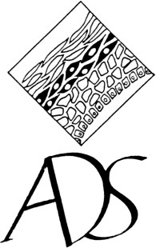

THE AUSTRALASIAN DERMATOPATHOLOGY SOCIETY

A Health Promotion Charity Limited by Guarantee
ABN 97 158 990 759
www.aderms.com

Annual General Meeting 2023 – Proxy Form
(Clause 10 of the Constitution)
For any vote at the AGM

I am a financial member of the Australasian Dermatopathology Society. I hereby appoint
⁭the Chair of the Meeting OR

(print name of person other than the Chair who is not you)

as my proxy to act generally at the meeting and on my behalf and to vote as I have directed my proxy to vote, or in the absence of such directions as my proxy sees fit at the Annual General Meeting of the Society to be held on Sunday 3rd of September 2023, at Sofitel Hotel, Melbourne.

Signature of Member

Name, email and contact phone number of Member (please print legibly)

Date

Return to: ads@arinex.com.au

